HOW TO UPLOAD DOCUMENTS USING THE SECURE DOCUMENT UPLOAD PORTAL
- Log into the ACCE Member Portal
- Click the Secure Document Upload tab on the lefthand side
  - If you do not see the Secure Document Upload tab, please reach out to the ACCE Benefits Team (accebenefitsteam@acce.org)
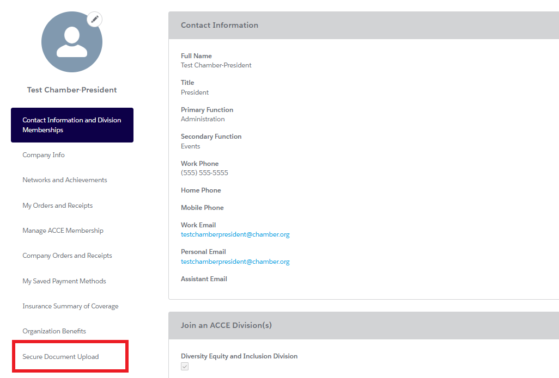
- On the Secure Document Upload page, you will see two sections:
  - Upload History: this section displays your upload history.
  - Upload New Document: upload new documents here
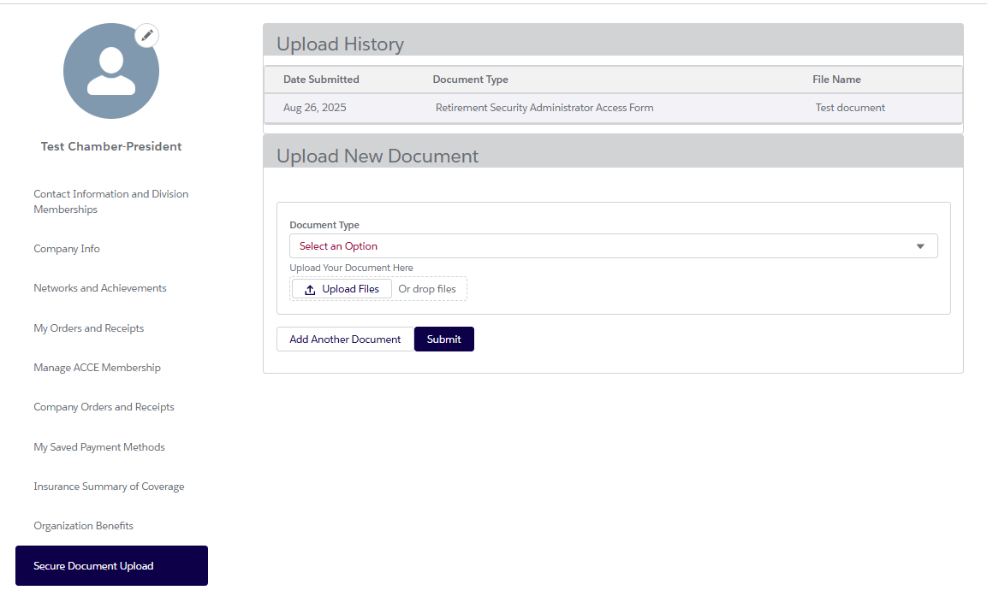
- In the Upload New Document section:
  - Select the Document Type from the dropdown
    - Payroll Report
    - Retirement Security Administrator Access Form
    - Insurance Administrator Access Form
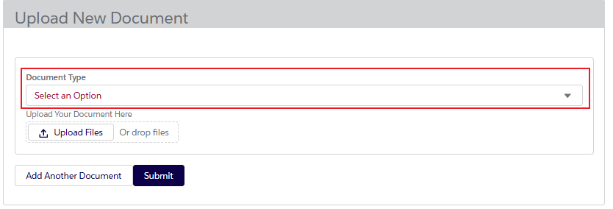
  - If you select Payroll Report, you will be asked for the Direct Deposit Date (Note: Please save the file as the exact Direct Deposit Date that is listed on the payroll report)
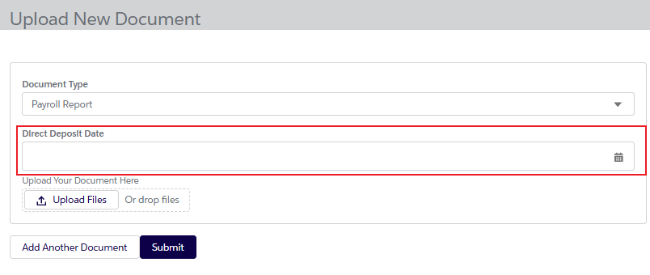
  - Click the Upload Files button and select the file from your computer
  - If you wish to add another document to this upload, click the Add Another Document button and repeat the same steps you took for the first document.
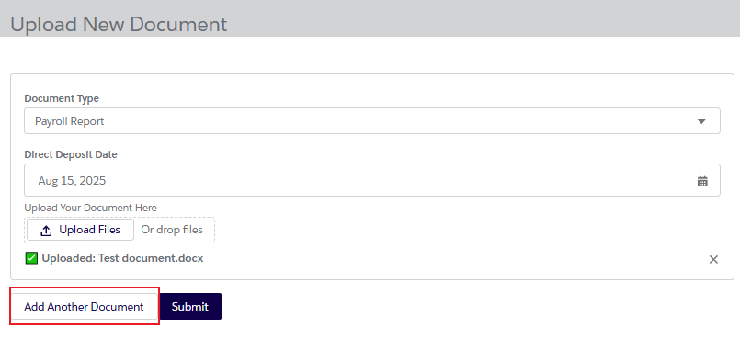
  - Once you have added all your documents, click the Submit button.
